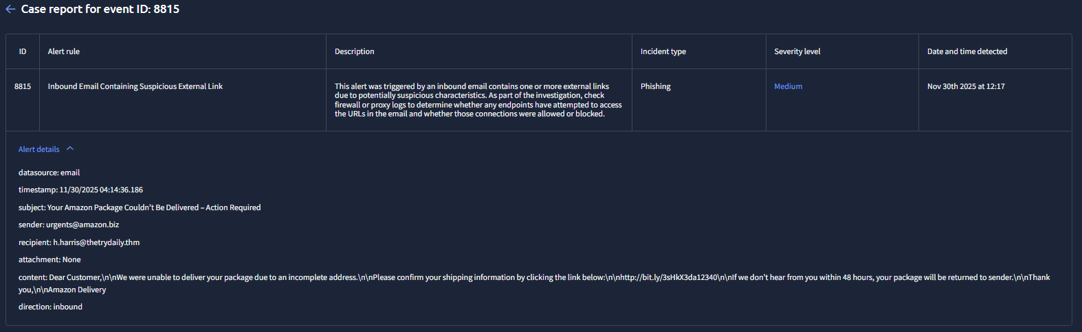
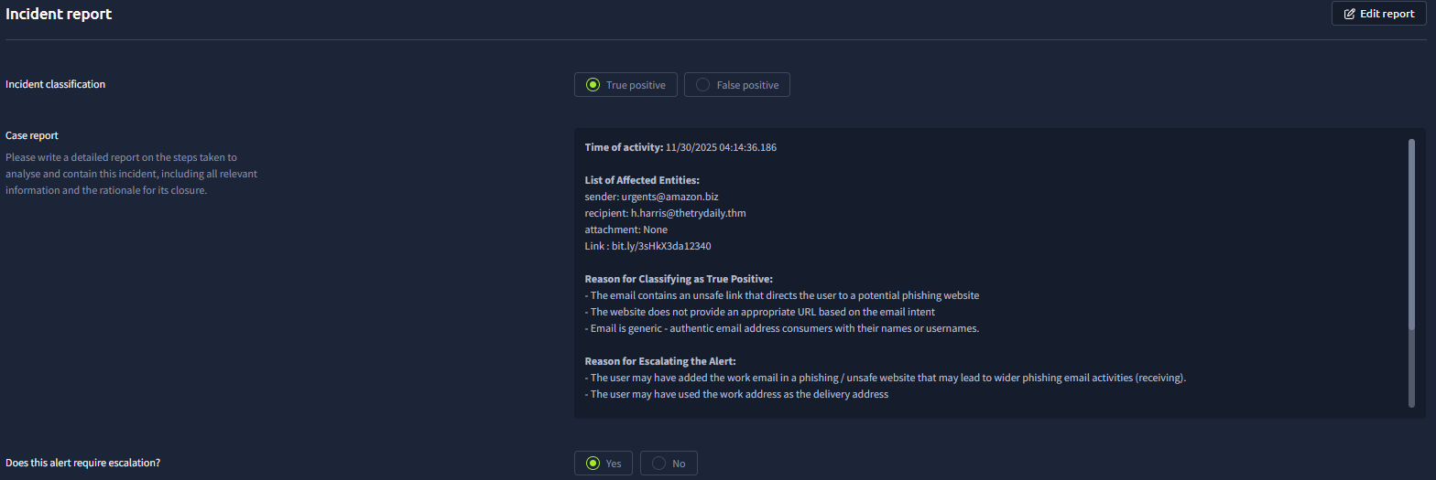

Complete IR:
Time of activity: 11/30/2025 04:14:36.186

List of Affected Entities:
sender: urgents@amazon.biz
recipient: h.harris@thetrydaily.thm
attachment: None
Link : bit.ly/3sHkX3da12340

Reason for Classifying as True Positive:
- The email contains an unsafe link that directs the user to a potential phishing website
- The website does not provide an appropriate URL based on the email intent
- Email is generic - authentic email address consumers with their names or usernames.

Reason for Escalating the Alert:
- The user may have added the work email in a phishing / unsafe website that may lead to wider phishing email activities (receiving).
- The user may have used the work address as the delivery address

Recommended Remediation Actions:
- User policy reminder
- pre-shift meeting or pocket training about proper use of work email and how to identify and deal phishing emails.
List of Attack Indicators:
- Social Engineering tactic: Urgency
- Suspicious link included in the email asking for valuable information (Address)

